### Institutions

Institutions represent the participating data contributors within the HIE. An institution might be a hospital, a practice, a state entity (e.g., Medicaid), an insurance provider, or another HIE. Each user must be associated with an institution in order to view patient data. Users may be associated with more than one institution.

To add an institution to a user's account, select from the **Add an Institution** dropdown.



To add more than one institution, wait until the *Added* confirmation message appears. Then, select the next institution, if applicable.

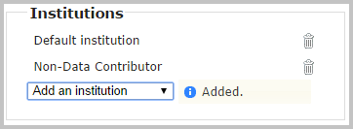

To delete an institution, click on the trash can icon next to an added institution. A *Deleted* confirmation message will appear briefly.



Users with the Clerk role (or other users who will register and opt-out patients from institutions that do not contribute data) should be assigned the **NonDataContributor** institution, in addition to any other assignments.